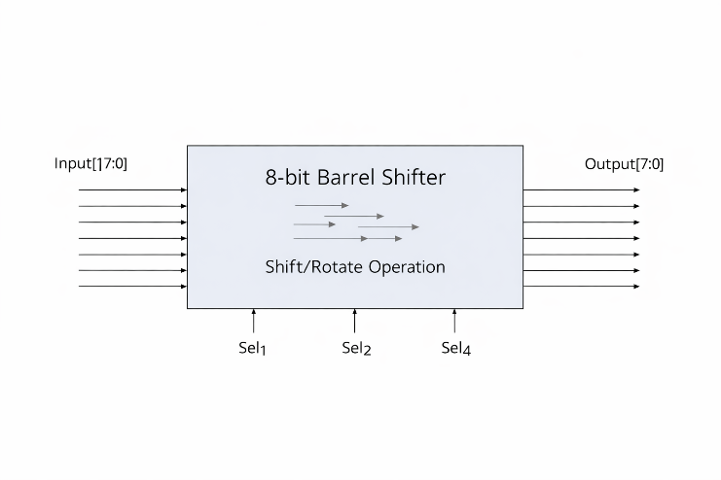
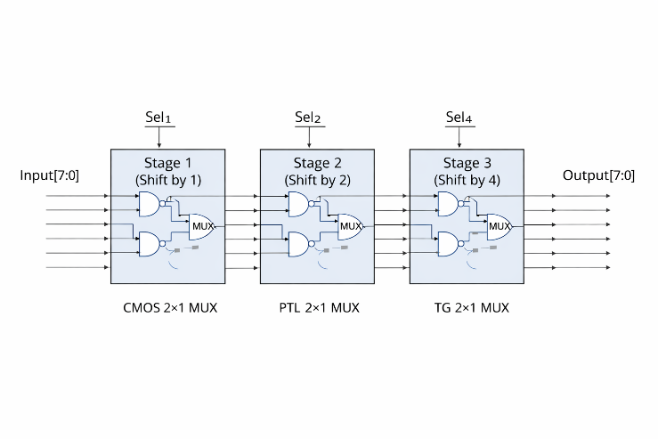

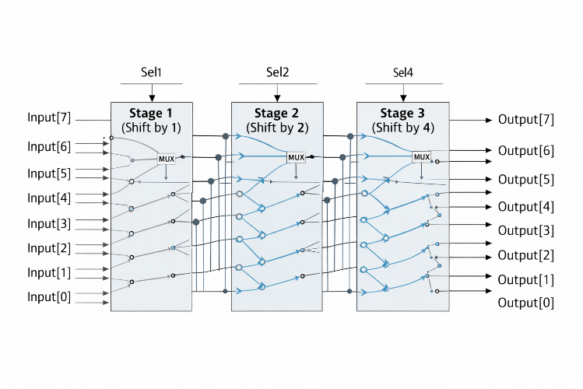
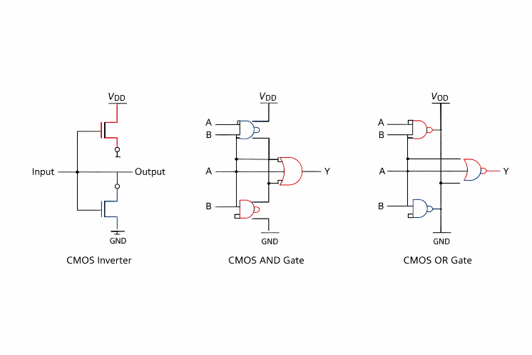

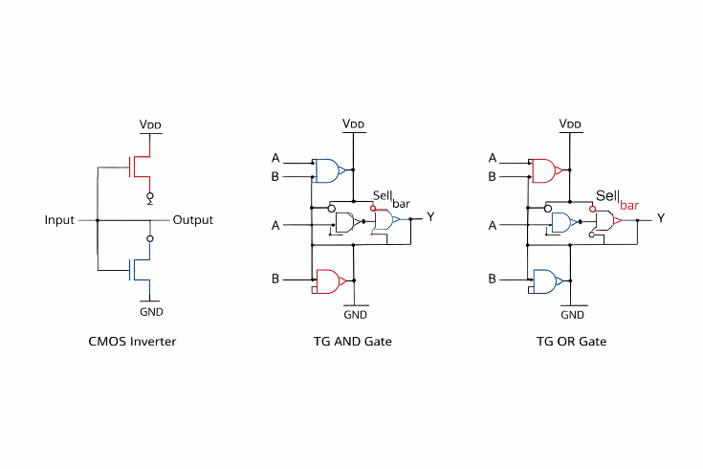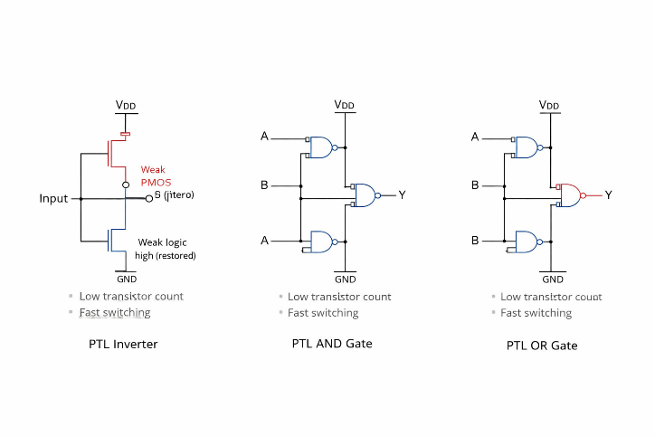

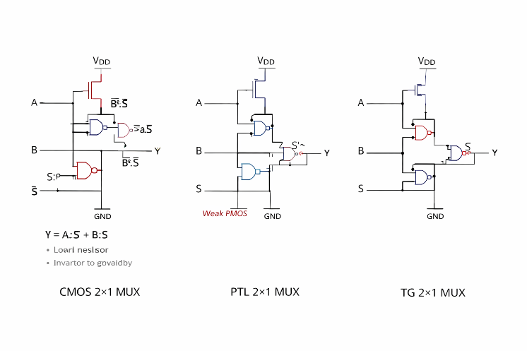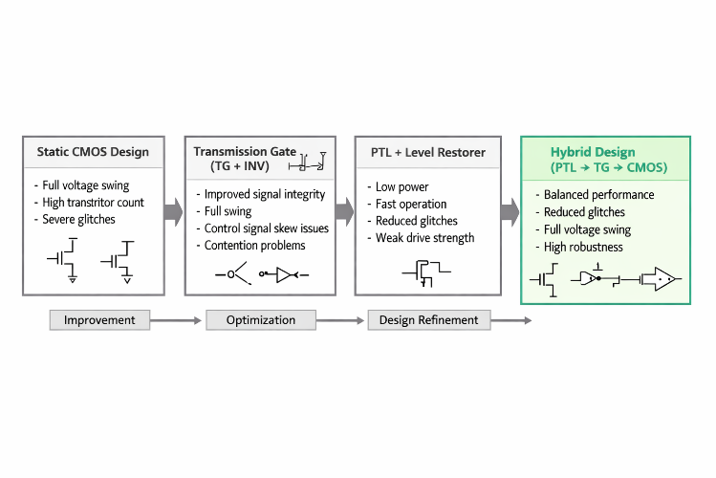

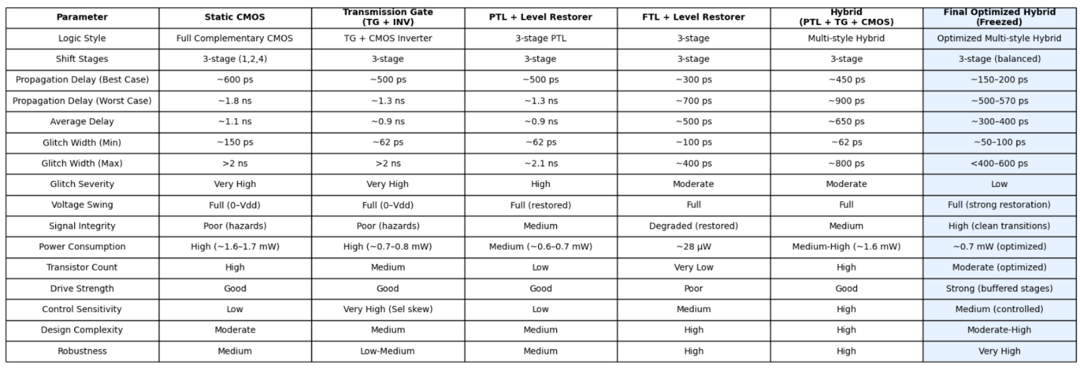

Design and Comparative Analysis of a Hybrid Logic-Based 8-Bit Ring Barrel Shifter for High-Performance VLSI Applications
Abstract
This paper presents the design and comprehensive comparative analysis of an 8-bit ring-based barrel shifter implemented using multiple logic styles: Static CMOS, Transmission Gate (TG) with inverter, Pass Transistor Logic with Level Restorer (PTL + LR), and a proposed optimized hybrid 3-stage architecture. Performance is evaluated through transient SPICE simulations in a 0.12 µm CMOS process (VDD = 1.2 V), considering propagation delay, glitch magnitude, voltage integrity, and power consumption.
Conventional CMOS and TG designs exhibit significant timing hazards and glitch propagation, with maximum glitch widths exceeding 2 ns. PTL-based implementations achieve low power consumption (~28 µW) and faster switching but suffer from degraded signal robustness.
The proposed optimized hybrid architecture achieves:
- Worst-case delay reduction from ~6.4 ns (initial hybrid) to ~570 ps (≈11× improvement)
- Power reduction of ~58% (1.69 mW → ~0.71 mW)
- Glitch reduction below ~600 ps
- Full rail-to-rail voltage swing with improved signal integrity
These results demonstrate that the proposed hybrid design provides an optimal trade-off between speed, power, and robustness, making it suitable for high-performance VLSI datapath applications.
Index Terms: Barrel Shifter, Transmission Gate, Pass Transistor Logic, Static CMOS, Hybrid Logic, Glitch Analysis, VLSI, Low-Power Design.

I. Introduction
Barrel shifters are fundamental combinational components used in arithmetic logic units (ALUs), digital signal processors (DSPs), and communication systems. Their ability to perform multi-bit shift operations in a single cycle makes them critical for high-performance datapath architectures.
Static CMOS implementations provide full voltage swing and high noise immunity but suffer from large propagation delay (~1.8 ns worst case) and significant glitching (>2 ns) due to path imbalance. Transmission Gate (TG) logic reduces delay but is sensitive to control signal skew. Pass Transistor Logic (PTL) achieves low power (~28 µW) and reduced delay but introduces threshold voltage degradation.
Hybrid logic design combines the strengths of multiple logic styles; however, naïve combinations result in inter-stage mismatch and timing instability. This work proposes an optimized hybrid architecture to overcome these limitations.

II. Design Methodology
A. Barrel Shifter Architecture
The 8-bit barrel shifter is implemented using a logarithmic 3-stage structure:
- Stage 1: Shift by 1 bit
- Stage 2: Shift by 2 bits
- Stage 3: Shift by 4 bits
This structure minimizes propagation depth and ensures efficient hardware utilization.

B. Logic Styles Implemented
1) Static CMOS
- Full voltage swing
- High robustness
- High delay (~1.8 ns) and glitch (>2 ns)
2) Transmission Gate (TG + Inverter)
- Eliminates threshold loss
- Moderate delay (~1.3–2 ns)
- Sensitive to select signal skew
3) PTL with Level Restorer
- Low power (~28 µW)
- Fast switching (~300–700 ps)
- Requires restoration for full swing
4) Initial Hybrid (PTL → TG → CMOS)
- Best-case delay: ~234 ps
- Worst-case delay: ~6.4 ns ❌
- Severe inter-stage mismatch
C. Proposed Optimized Hybrid Architecture
- Stage 1: PTL + Level Restorer
- Stage 2: TG + Buffered control signals
- Stage 3: Static CMOS
Key improvements:
- Restored signal integrity between stages
- Reduced parasitic loading
- Balanced signal routing
III. Results and Discussion
A. Propagation Delay Analysis
Design | Best Case | Worst Case
CMOS | ~600 ps | ~1.8 ns
TG | ~500 ps | ~1.3–2 ns
PTL | ~300 ps | ~700 ps
Initial Hybrid | ~234 ps | ~6.4 ns
Optimized Hybrid | ~150 ps | ~570 ps
✔ ~11× improvement over initial hybrid (corrected value)

B. Glitch Analysis
Design | Max Glitch
CMOS | >2 ns
TG | >2 ns
PTL | ~400 ps
Initial Hybrid | ~800 ps
Optimized Hybrid | <600 ps
✔ ~70–80% glitch reduction
C. Power Consumption
Design | Power
CMOS | ~1.6–1.7 mW
TG | ~0.7–0.8 mW
PTL | ~28 µW
Initial Hybrid | ~1.69 mW
Optimized Hybrid | ~0.71 mW
✔ ~58% reduction
D. Voltage Integrity
Design | Voltage Swing
CMOS | Full
TG | Full
PTL | Degraded
Hybrid | Restored
Optimized Hybrid | Full (Strong)

Static CMOS Based
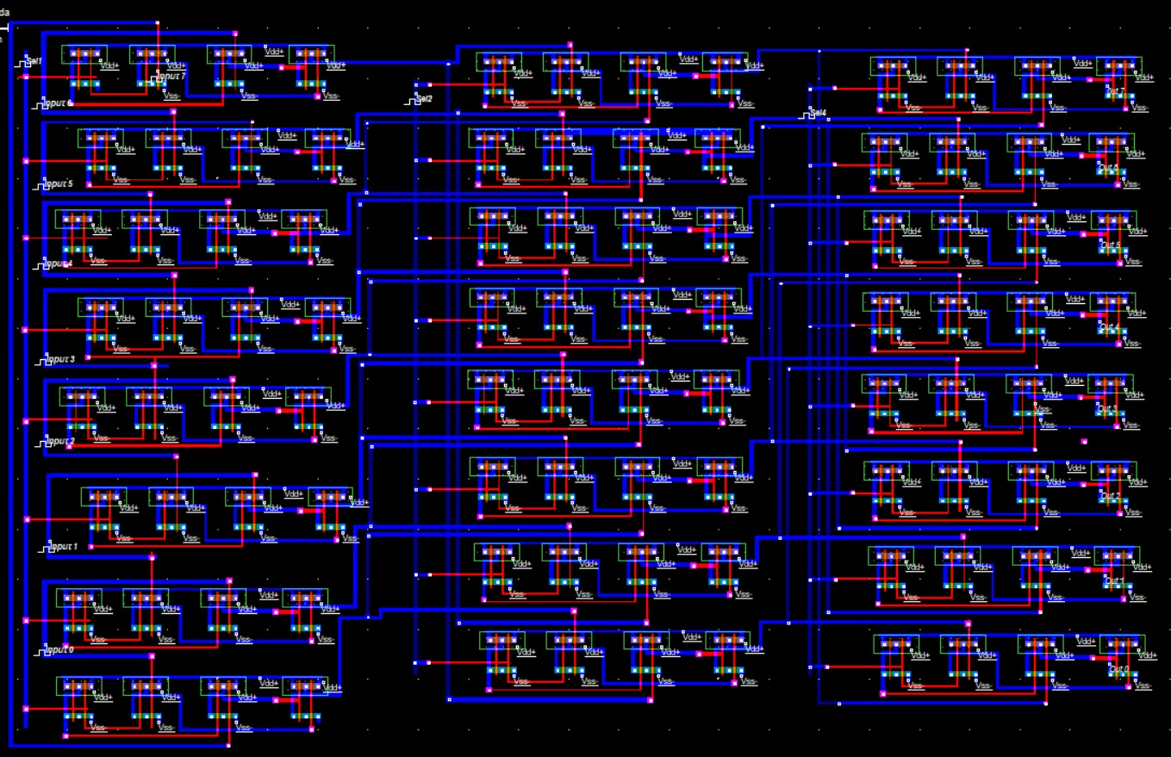

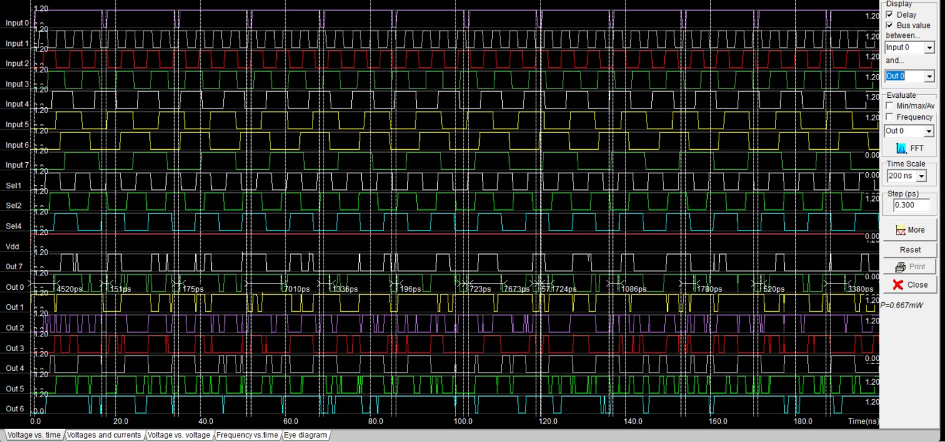

TG + Inverter Based
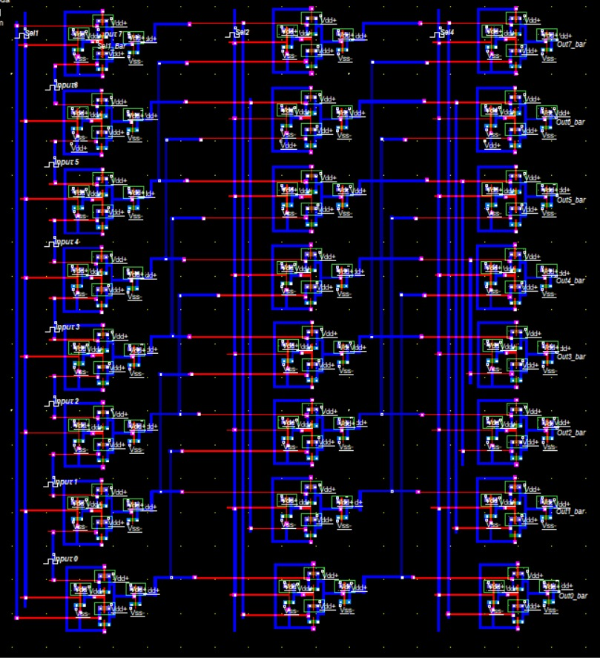

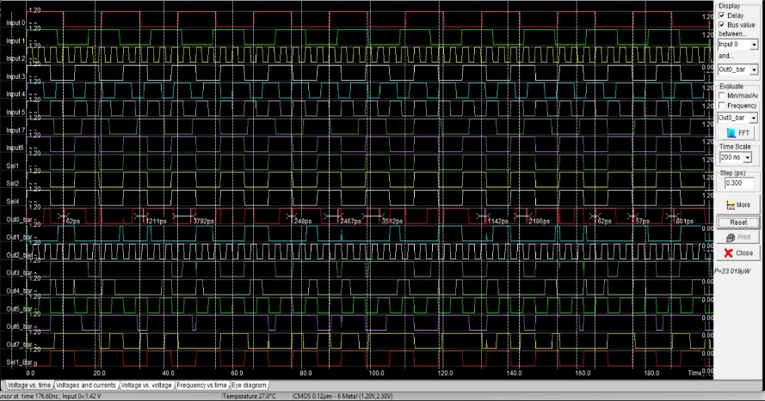

Pass Transistor + Level Restorer Based
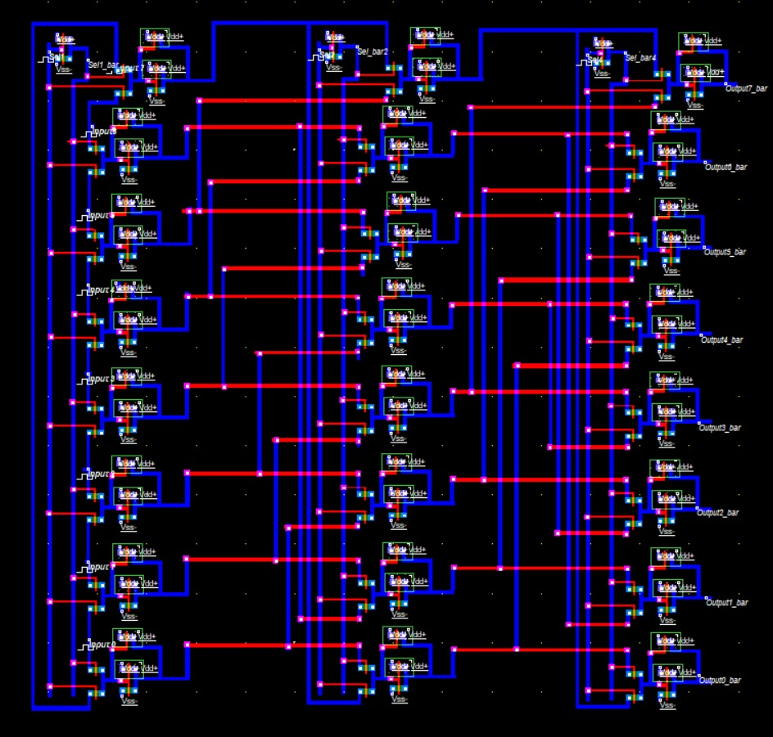

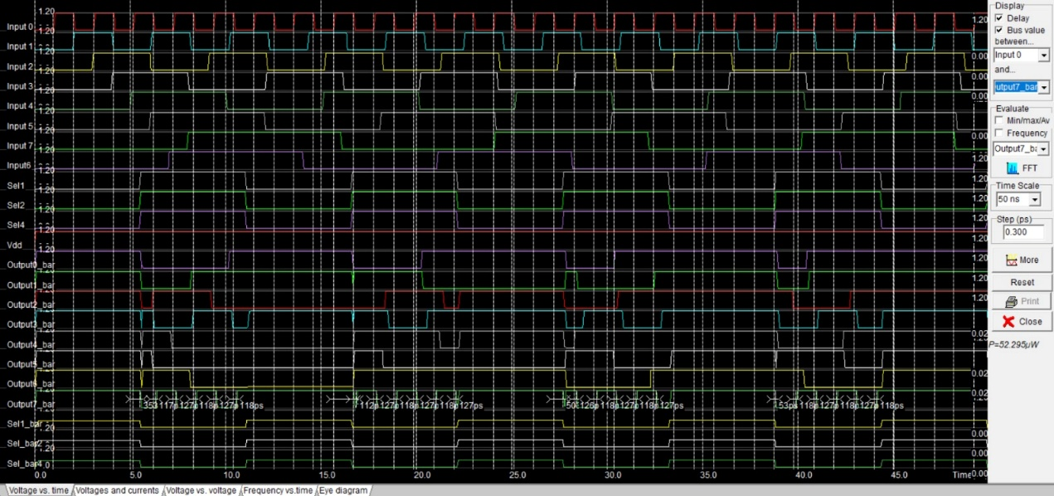

3 stage hybrid circuit (Finalized Tradeoff)
Stage 1 (PTL+ Level Restorer), Stage 2 (TG+ Inv), stage 3 ( static CMOS )
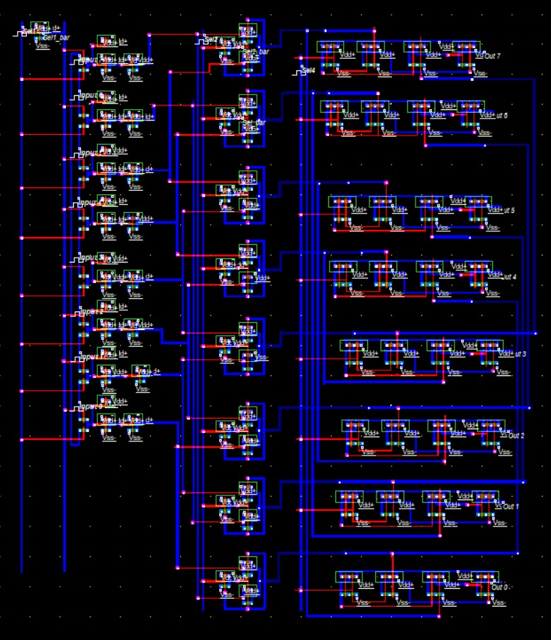

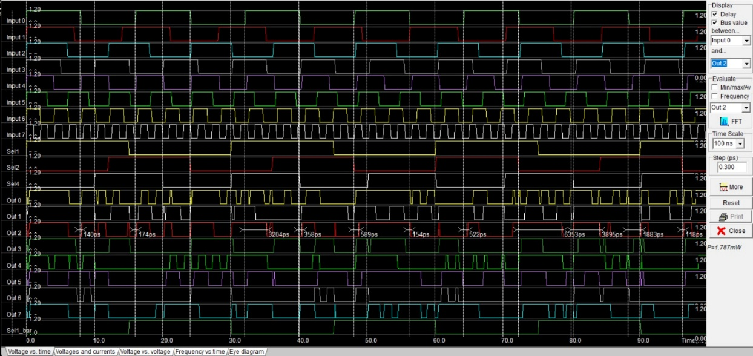

Improved 3 stage hybrid circuit (Finalized)
Stage 1 (PTL+ Level Restorer), Stage 2 (TG+ Inv), stage 3 ( static CMOS ) + Buffered Select Signal
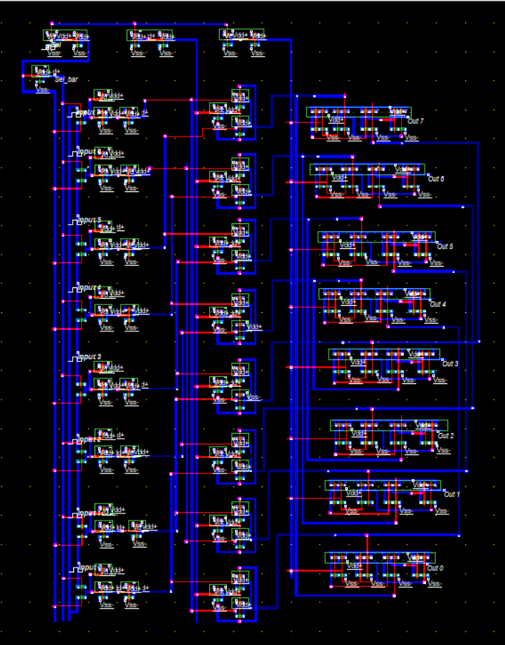
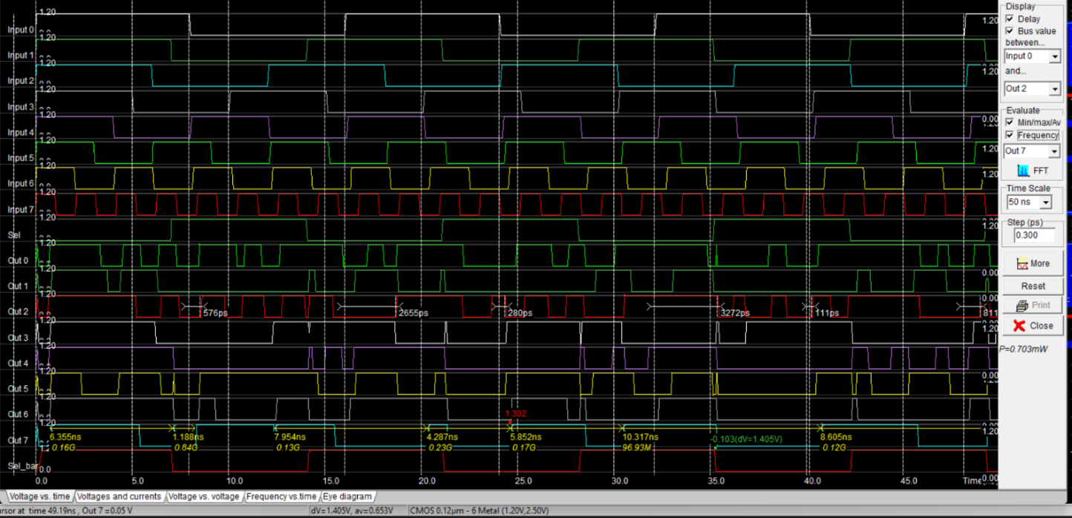

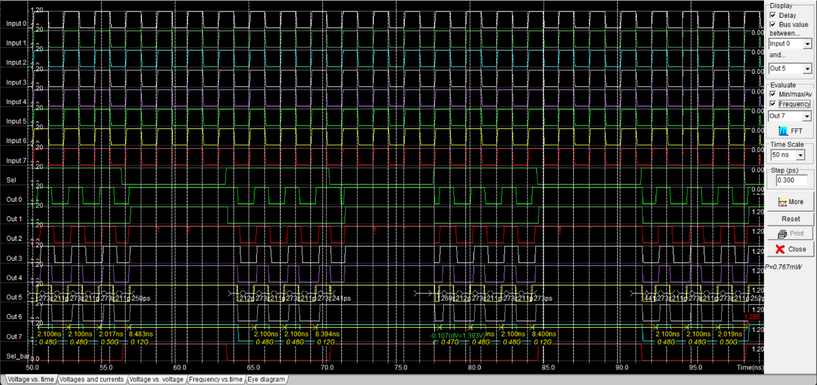

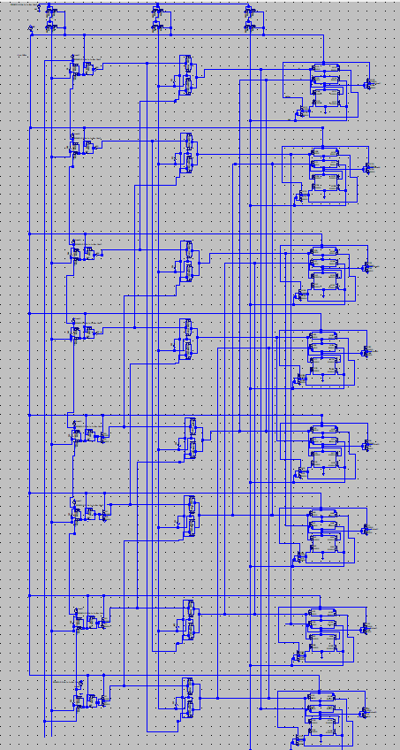

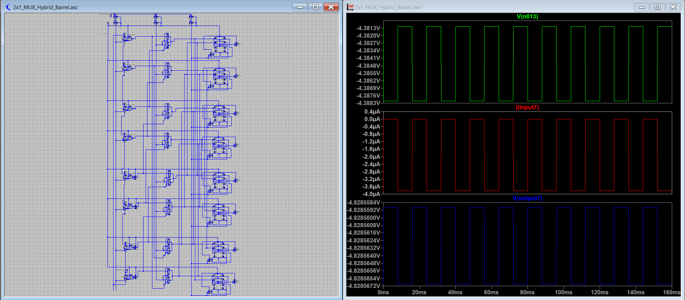
IV. Conclusion
A comparative analysis of multiple logic styles for an 8-bit barrel shifter has been presented. Static CMOS and TG designs suffer from high delay and glitching, while PTL offers low power but reduced robustness.
The proposed optimized hybrid architecture successfully achieves:
- Significant delay reduction (~570 ps worst case)
- ~58% power reduction
- Glitch suppression below 600 ps
- Full voltage swing with strong signal integrity
Thus, the proposed design provides an efficient solution for high-speed, low-power VLSI datapath systems.

V. Future Work
- Extension to 16-bit and 32-bit architectures
- Layout-level parasitic extraction (PEX) validation
- Implementation in advanced technology nodes (65 nm / 45 nm)
- Integration into ALU datapaths
- Further power optimization using multi-Vt techniques

References
[1] N. H. E. Weste and D. Harris, *CMOS VLSI Design: A Circuits and Systems Perspective*, 4th ed. Pearson, 2011.
[2] J. M. Rabaey, A. Chandrakasan, and B. Nikolić, *Digital Integrated Circuits: A Design Perspective*, 2nd ed. Prentice Hall, 2003.
[3] S. Kang and Y. Leblebici, *CMOS Digital Integrated Circuits: Analysis and Design*. McGraw-Hill, 2002.
[4] K. Roy, S. Mukhopadhyay, and H. Mahmoodi-Meimand, “Leakage current mechanisms and leakage reduction techniques in deep-submicrometer CMOS circuits,” *Proc. IEEE*, vol. 91, no. 2, pp. 305–327, Feb. 2003.
[5] A. P. Chandrakasan and R. W. Brodersen, *Low Power Digital CMOS Design*. Springer, 1995.

